Objective: Understand Azure cloud concepts and build an end-to-end data pipeline using Storage Account and Azure Data Factory.
Step 1. Resource Group:
First, I created a Resource Group (named rg_celebal_week4). This is like a folder that holds all the resources for this project together, so it's easier to manage and clean up later.
Resource Group overview page:
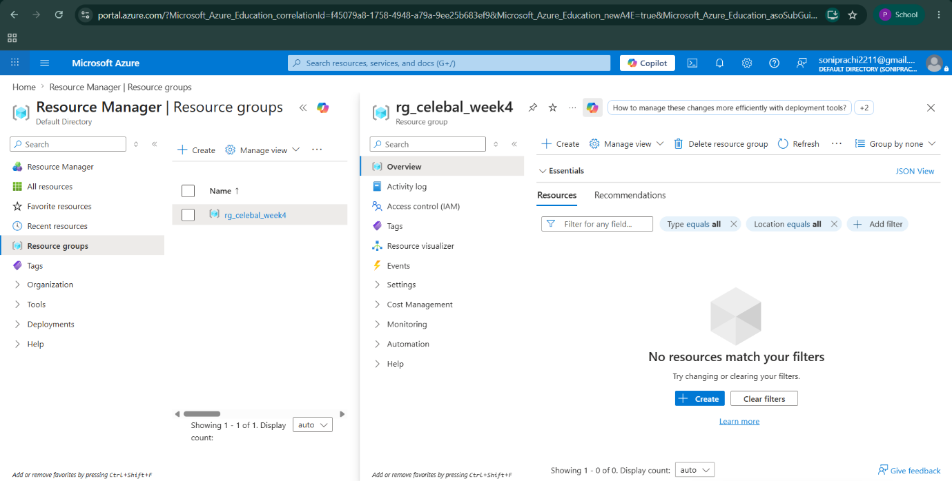
Step 2. Storage Account:
Next, I created a Storage Account (named storagecelebalweek4). This is where I'll store the data files that need to be processed and two Blob Containers are configured:
- source-container
- destination-container
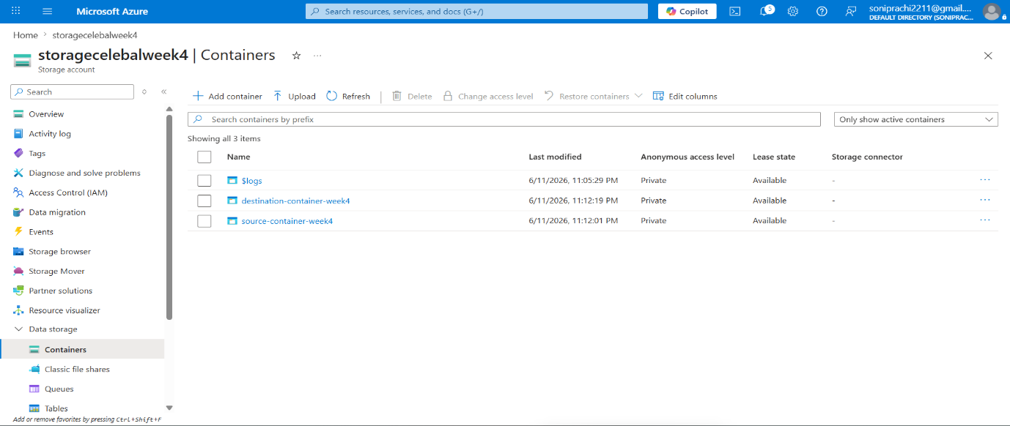
Step 3. Upload CSV Files:
Inside the storage account, I created a container (named source-container-week4) and uploaded a CSV file into it. This file will be the source data for my pipeline.
Container with the uploaded CSV:
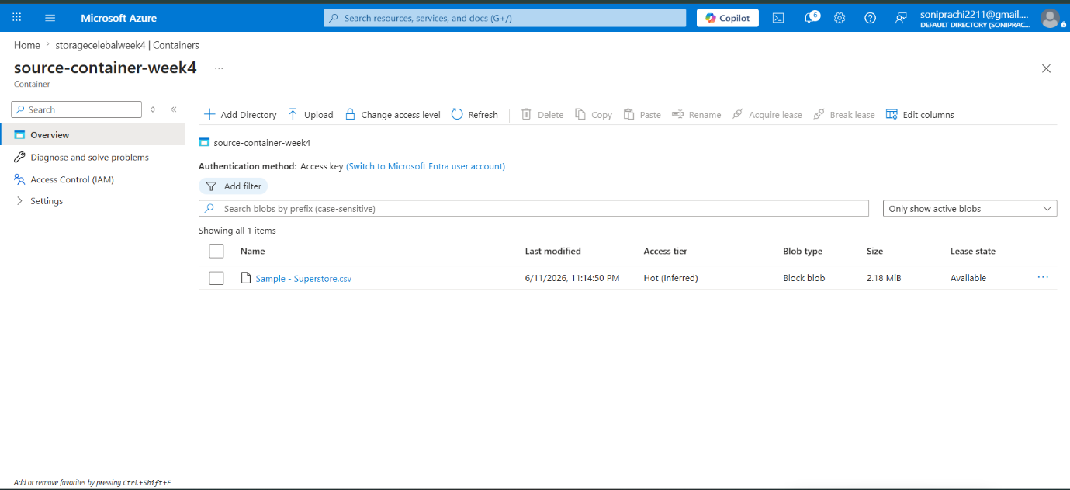

Step 4. Azure Data Factory:
Then I created an Azure Data Factory (named ADF-celebalweek4). This is the tool that will actually move the data from one place to another.
ADF overview page:
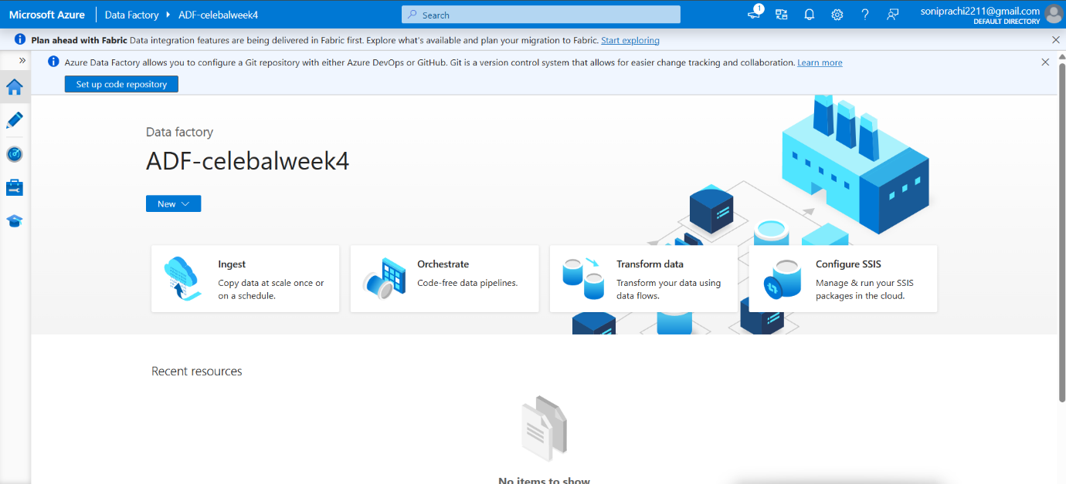

Step 5. Linked Service:
I created a Linked Service to connect my Data Factory to my Storage Account. This is basically telling ADF where my data lives and giving it permission to access it.
Linked service setup page:
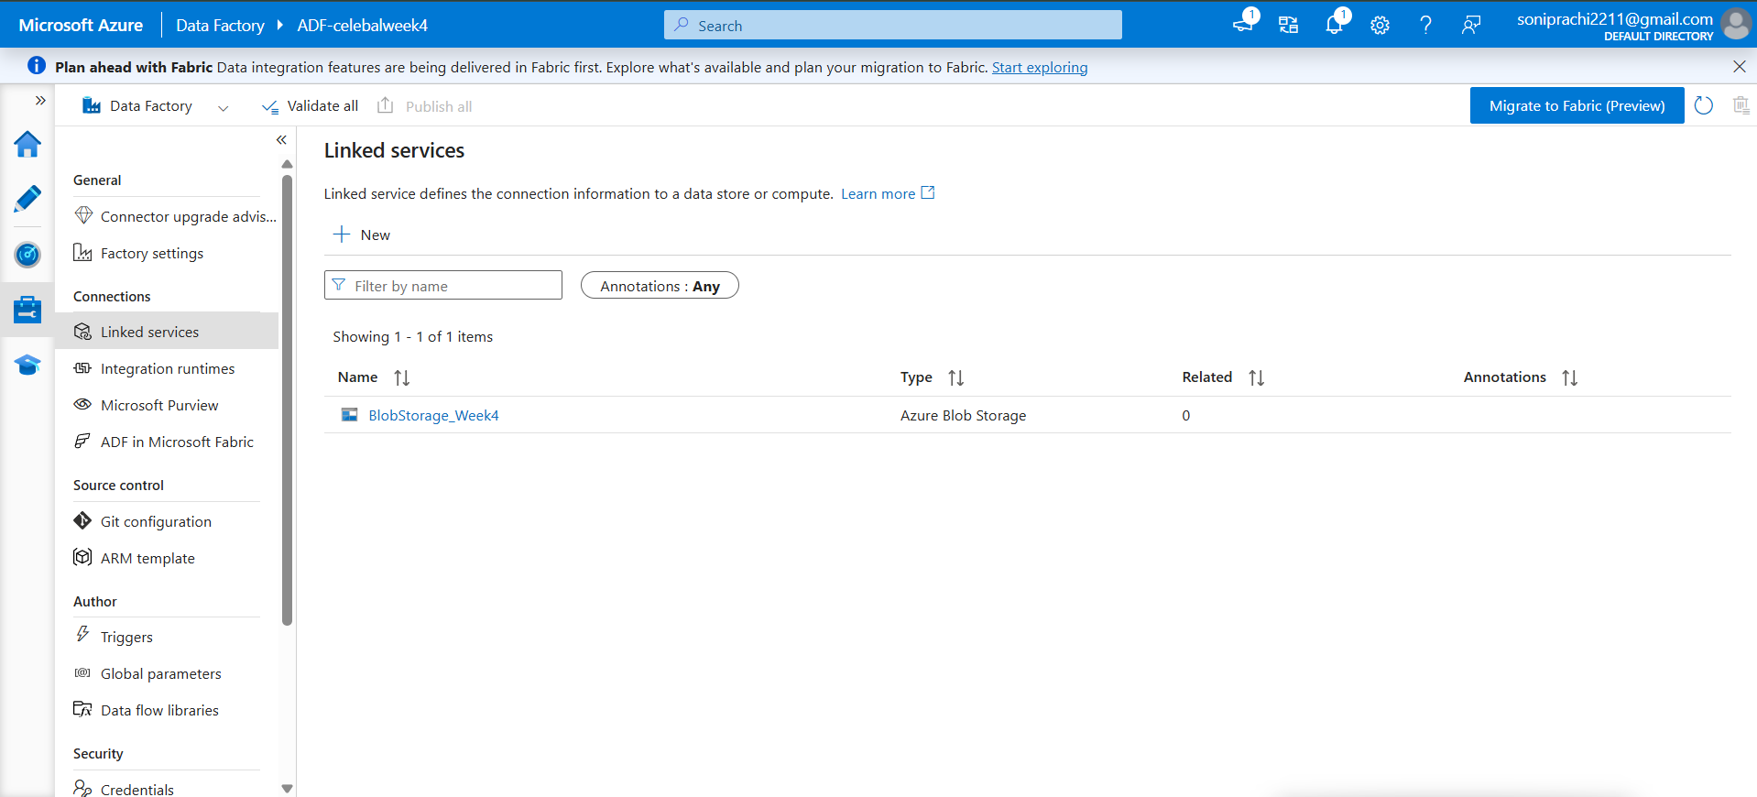

Step 6. Datasets (Source and Destination):
I set up two datasets - one for the source (the CSV file I uploaded named DS_source) and one for the destination (where the copied file should go named DelimitedText1).
Source and sink dataset configuration:
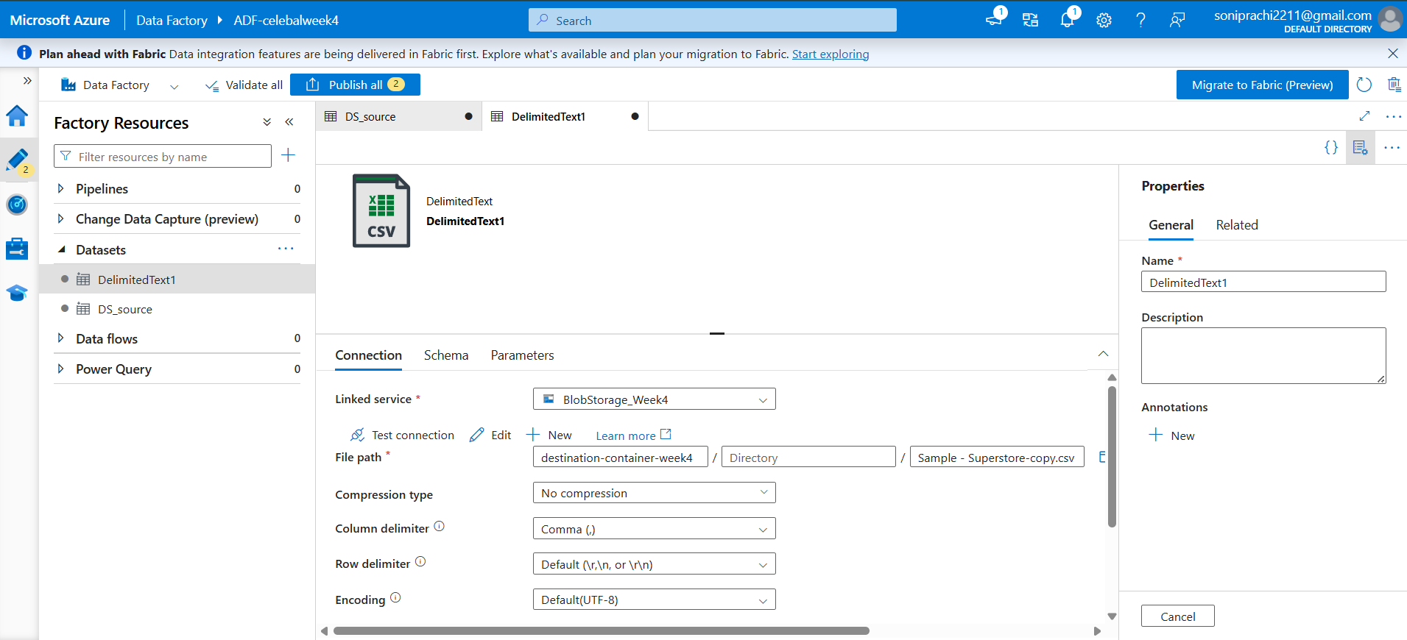

Step 7. Get Metadata Activity:
Before copying the file, I added a Get Metadata activity. This checks details about the file, like its name and size, just to make sure it's there and correct before moving it.
Get Metadata settings:
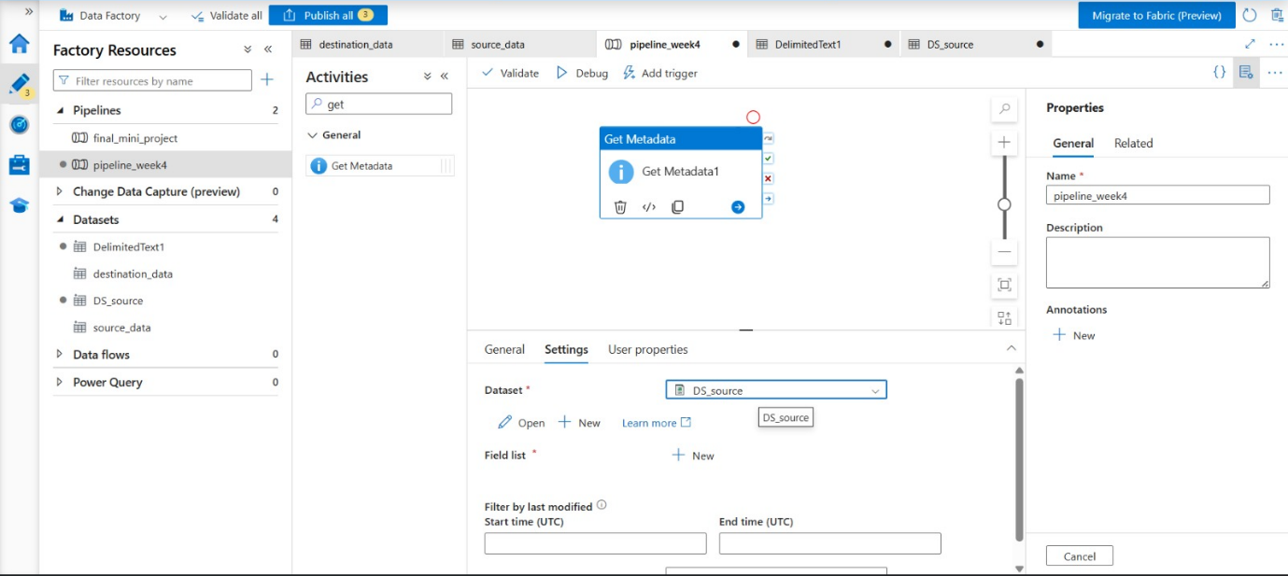

Step 8. Pipeline with Copy Data Activity:
I built the pipeline (named pipeline-week4) by adding a Copy Data activity after the Get Metadata step. This copies the file from the source location to the destination.
Full pipeline canvas:
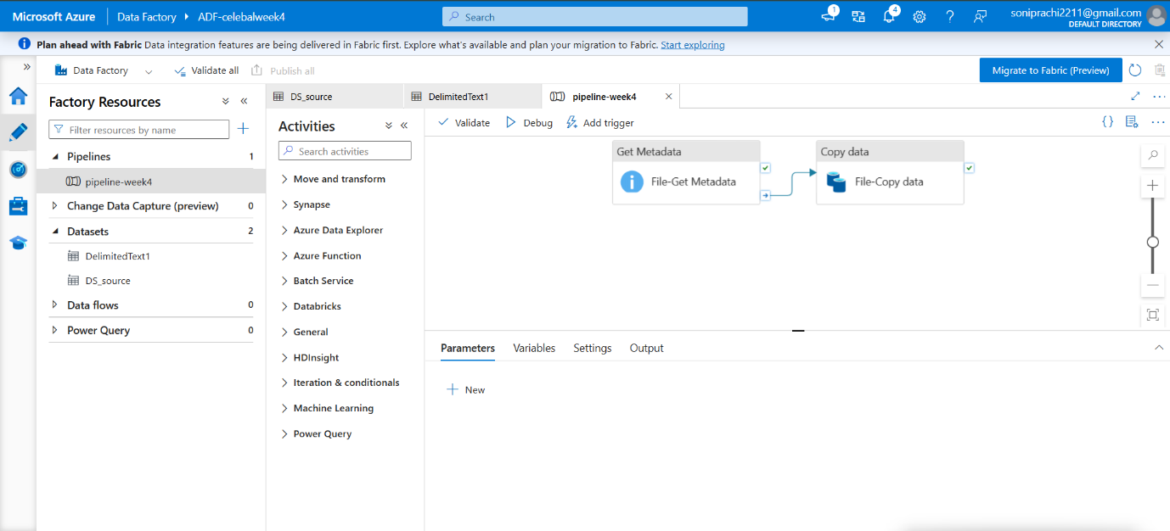

Step 9. Pipeline Debug:
I ran the pipeline in Debug mode to test it. Both steps completed successfully, shown by the green ticks.
Debug output showing green checkmarks:
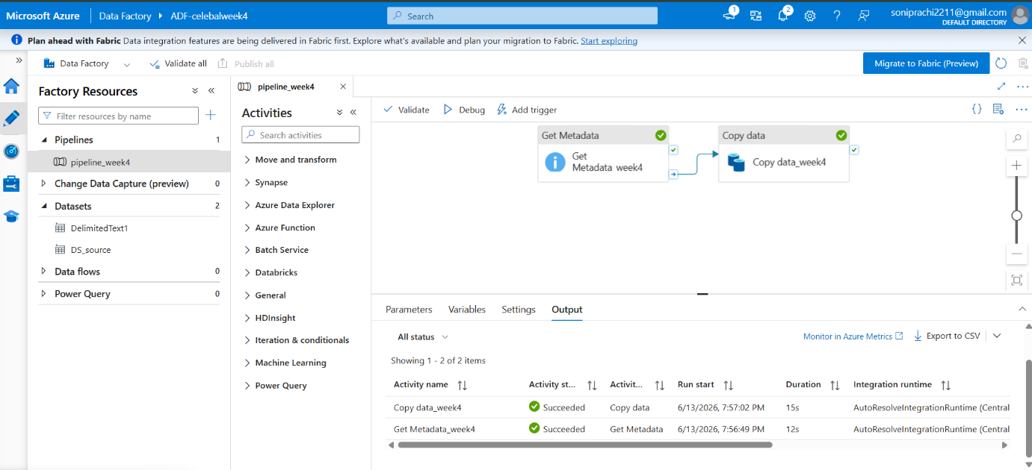

Step 10. Output Validation:
I built the main pipeline with a Copy Data activity, which moves the file from the source to the destination container.
The file is successfully copied to destination container.
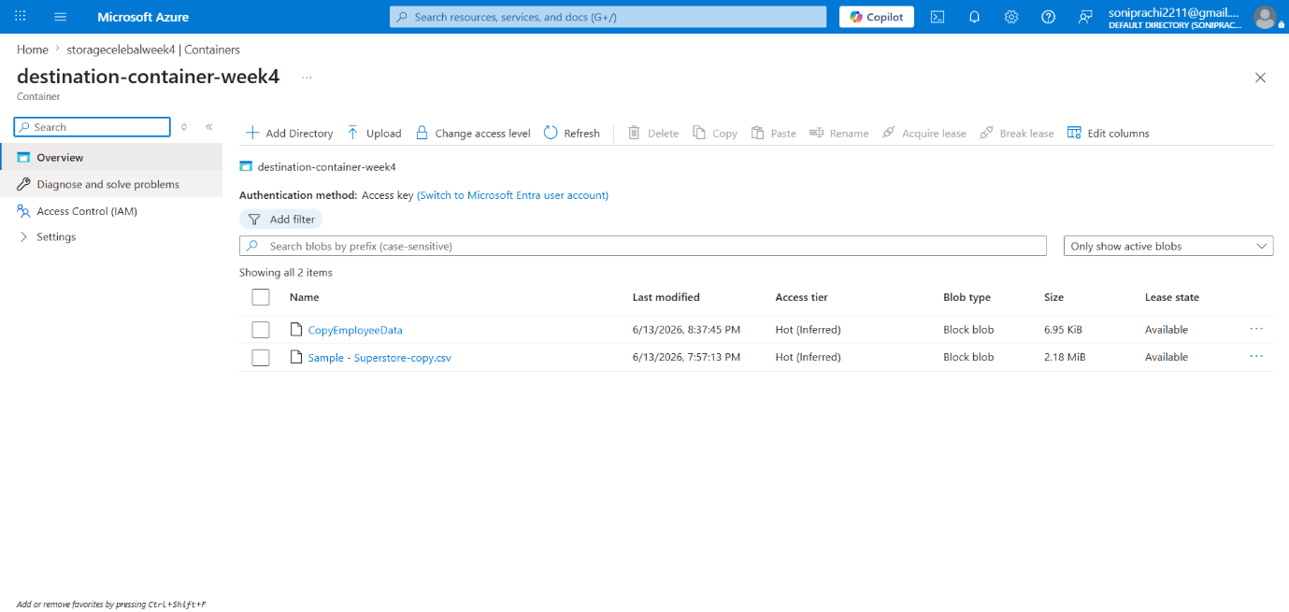

Step 11. IAM Roles:
Finally, I went to the Storage Account's Access Control settings and assigned Reader and Contributor roles to Data Factory. This gives ADF the permission it needs to read and write data in the storage account.
Access Control (IAM) page showing assigned roles:
